CASE STUDY ON

AWS CLOUDFRONT

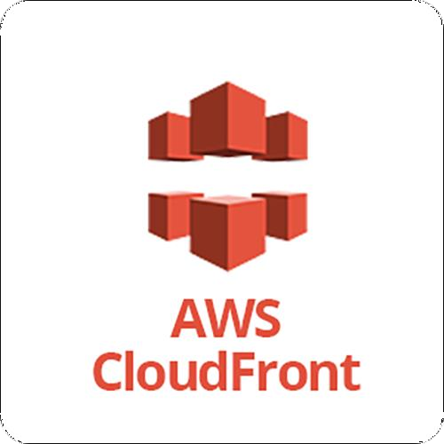

**INTRODUCTION**

**Amazon CloudFront** is a web service that speeds up distribution of your static and dynamic web content, such as .html, .css, .js, and image files, to your users. CloudFront delivers your content through a worldwide network of data centers called edge locations. When a user requests content that you're serving with CloudFront, the request is routed to the edge location that provides the lowest latency (time delay), so that content is delivered with the best possible performance

* If the content is already in the edge location with the lowest latency, CloudFront delivers it immediately.
* If the content is not in that edge location, CloudFront retrieves it from an origin that you've defined—such as an Amazon S3 bucket, a Media Package channel, or an HTTP server (for example, a web server) that you have identified as the source for the definitive version of your content

CloudFront speeds up the distribution of your content by routing each user request through the AWS backbone network to the edge location that can best serve your content. Typically, this is a CloudFront edge server that provides the fastest delivery to the viewer. Using the AWS network dramatically reduces the number of networks that your users' requests must pass through, which improves performance. Users get lower latency—the time it takes to load the first byte of the file—and higher data transfer rates

**HANDS ON**

**Step 1:** First we have to create a bucket in **s3** and have to upload a file in that for demo purpose, I am uploading one html file and one png file. So open S3 and click on create bucket.

**Step 2:** Give the name of your bucket ,keep all things as default and click on create bucket.

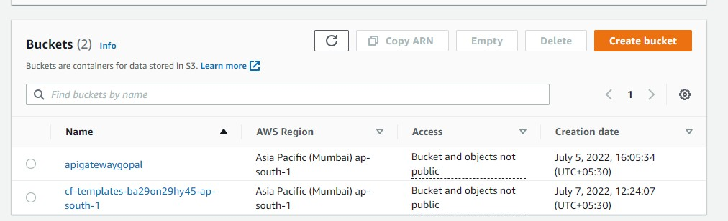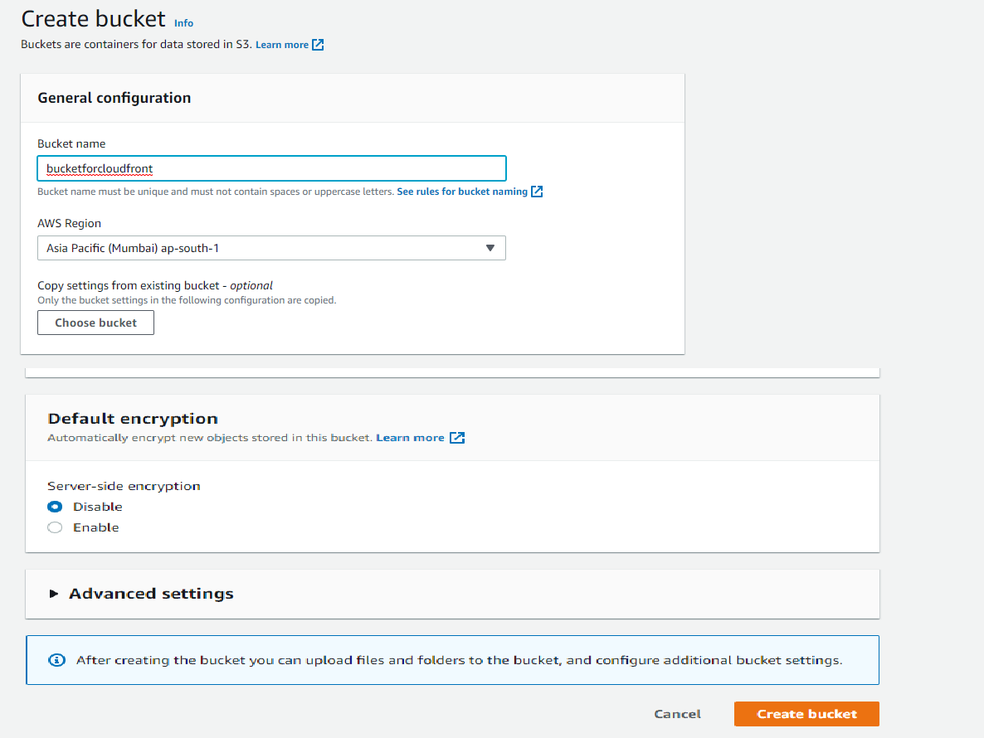

**Step 3:** You can see your bucket has been created. Now upload your files in that bucket

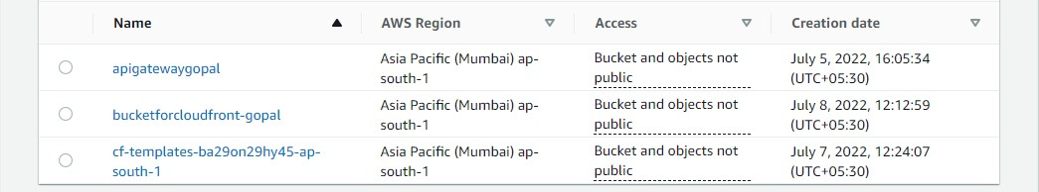

**Step 4:** I am uploading one index.html file which is shown below. To upload go to your bucket and click on Upload and select the files to be uploaded.

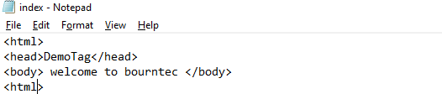

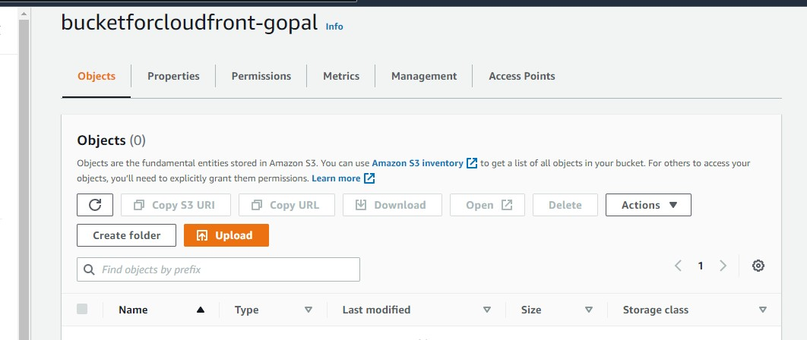

**Step 5:** After selecting your files click on Upload

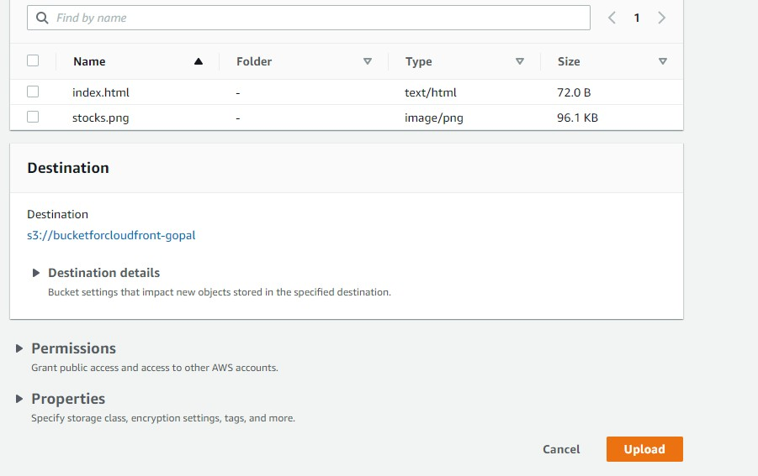

**Step 6:** You can see your files has been successfully uploaded in the bucket.

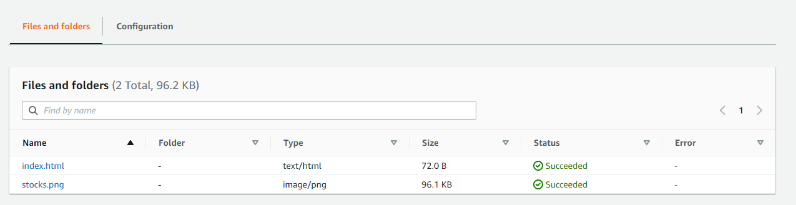

**Step 7:** Now type **cloudfront** in search bar of the management console and click on create a **cloudfront distribution**

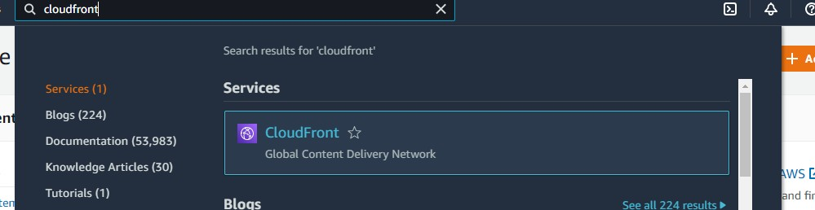

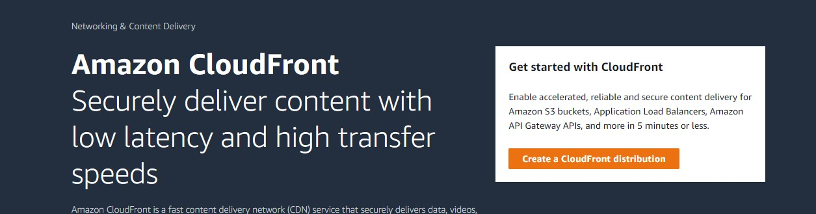

**Step 8:** Select origin domain same as your bucket name.

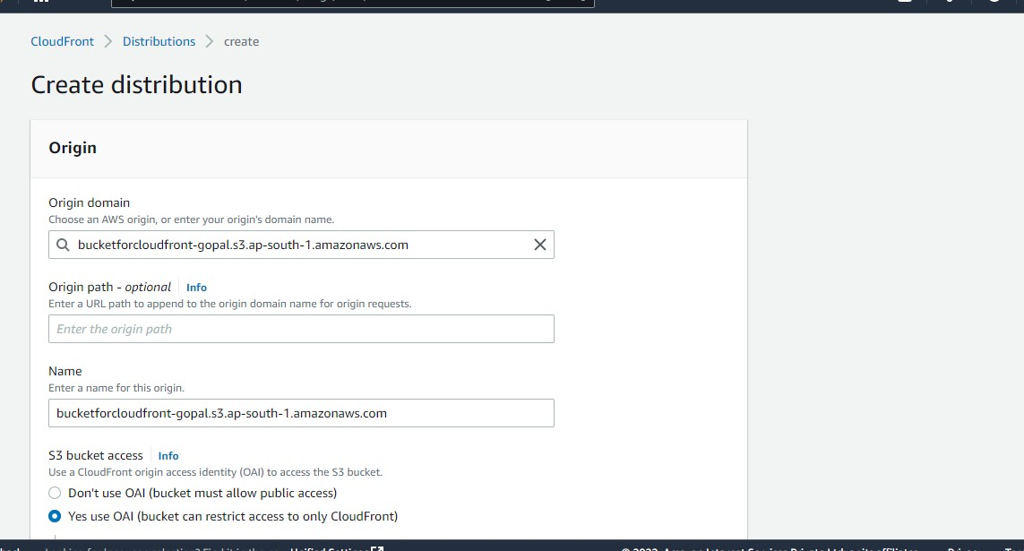

**Step 9:** In s3 bucket access click on yes , then click on create new OAI and click on yes update the bucket policies.

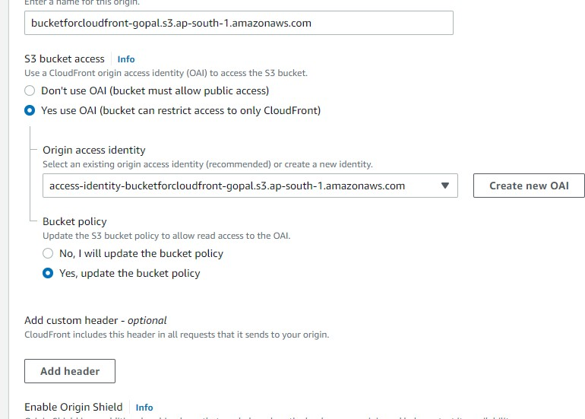

**Step 10:** You can see status as enabled and deploying.

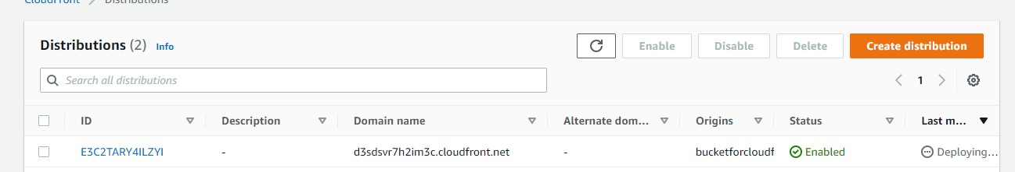

**Step 11:** Once it is deployed copy the the domain name.

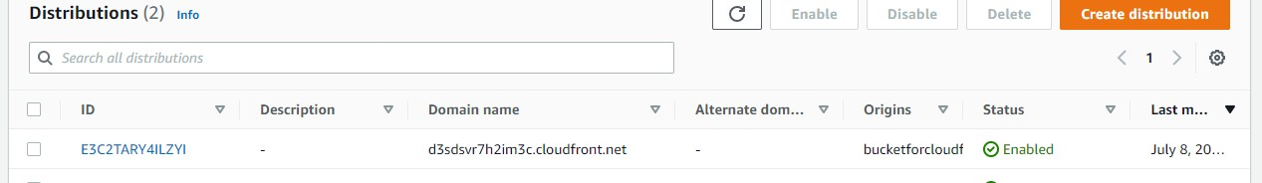

**Step 12:** Paste the link in new tab and we can see the html page open .

**Note** if it is not opened you can try /index.html after the link



**Step 13:** To open the stocks.png file give the link

**/stocks.png** after the end of the domain name.

